www.pattyhall.com PATTY HALL www.pattyhall.com
NATIVE DAUGHTER OF THE GOLDEN WEST®

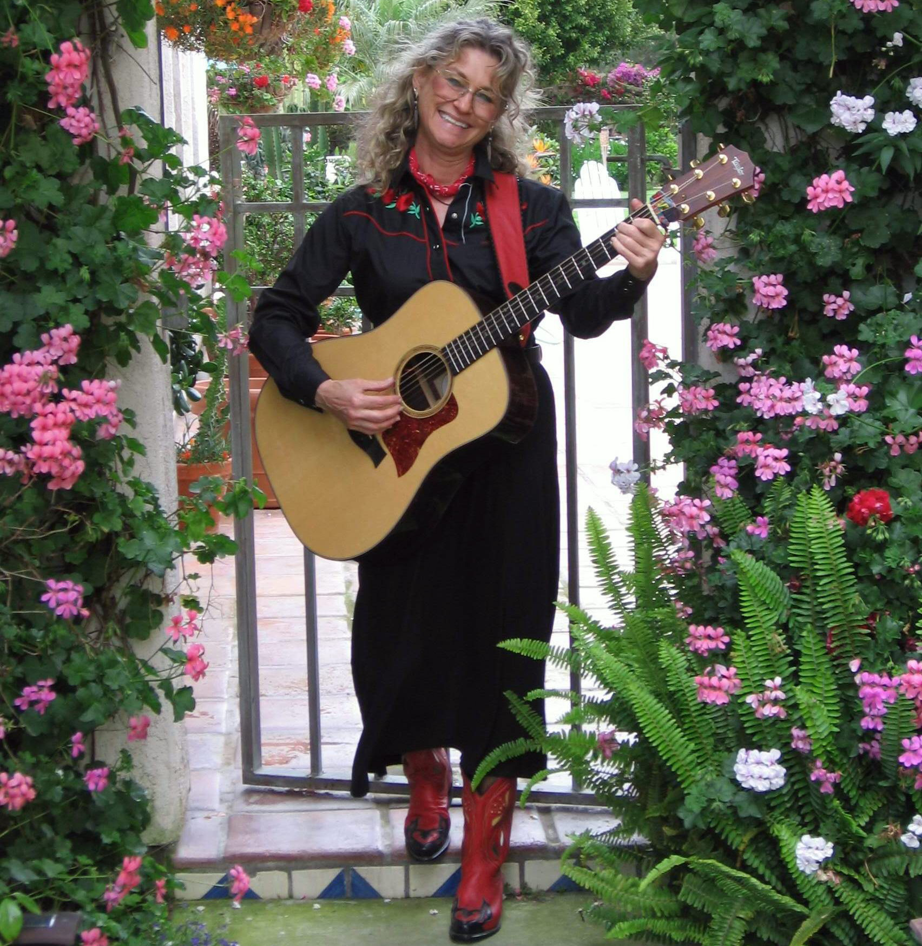

BORDERS BOOKS & MUSIC - STOCKTON

10776 Trinity Parkway – Stockton – CA

FRIDAY - SEPTEMBER 22, 2006
7-9 PM

Come out to BORDERS BOOKS & MUSIC – STOCKTON to hear San Diego singer/songwriter/folklorist/author PATTY HALL share her best and newest NATIVE DAUGHTER® music--a unique blend of traditional and original material rendered on guitar, banjo, and a cappella. Her CD, JUST BE GLAD! will be available for sale. For more info, call 209-951-2226 or visit:
www.pattyhall.com



